**CUSTOMIZED AI KITCHEN**

**FOR INDIA**

Harshwardhan Jain

Department of Computer Science and Engineering, The Northcap University, Data Science Specialization

[harshwardhan22csu392@ncuindia.edu](mailto:harshwardhan22csu392@ncuindia.edu)

Shefali Khera

Department of Computer Science and Engineering, The Northcap University, Data Science Specialization

[shefali22csu426@ncuindia.edu](mailto:shefali22csu426@ncuindia.edu)

Dr. Srishti Sharma

Department of Computer Science and Engineering, The Northcap University

srishtisharma@ncuindia.edu

Supported by Intel Corporation

June 20th, 2024

**Problem Statement**

**Description:**

We are in the world of AI (Artificial Intelligence) now, and the idea here is to develop an AI Kitchen Model for customized dishes. It’s one of the challenges that we face every day to prepare dishes on time at home. There could be AI based Vending Machines, Coffee and Bread making Products in the market now. But, this will not cover all the dishes that users may prefer. Another bigger issue is to get cooking utensils, which must be ready/cleaned. We have equipment like Washing Machines. But, it requires manual intervention to put utensils for washing or remove the same after washing. The idea here is to address this issue as well. Pick the right utensil based on the quantity of food. The idea is to integrate the 2 requirements of AI enabled Kitchen and Utensil Washing, and connecting them with each other.

**Deliverables:**

1. Come up with an AI model with Training to cook users’ choice of dishes, including ingredient and quantity selection.

2. Programming option to detect right utensils and to raise request to get the utensils from Washing Machine automatically.

3. Indication of raw materials required, and notify if they are not present.

4. Give a Non Microwave Oven option, and come up with requirements to integrate that with the AI Kitchen model.

**Team Members**

**Team Name: Tech Pioneers**

**1. Harshwardhan Jain**

**- Roles:** Lead Developer, Frontend Developer, Integration Specialist, Technical Writer, AI Specialist, Backend Developer

**- Contribution:**

1. Developed the Flask-based web application.

2. Enhanced the frontend user experience.

3. Integrated the AI model with the web application.

4. Managed the overall workflow and system integration.

5. Collaborated on backend development and TensorFlow model training.

6. Edited and guided the final report documentation.

**- Contact Info.:** harshwardhan22csu392@ncuindia.edu

**2. Shefali Khera**

**- Roles:** Data Scientist, Quality Assurance (QA) Tester, AI Specialist, Backend Developer

**- Contribution:**

1. Managed and preprocessed the recipe dataset.

2. Handled image processing for model input.

3. Conducted thorough testing of the application.

4. Evaluated the performance of the AI model to ensure accuracy.

5. Collaborated on backend development and TensorFlow model training.

**- Contact Info.:** shefali22csu426@ncuindia.edu

**Our Unique Solution**

To address the problem of developing an AI-enabled kitchen model that can prepare customized dishes and handle ingredient management, we have devised a comprehensive solution integrating artificial intelligence, machine learning, and automation. This solution comprises several key components designed to enhance the cooking experience and streamline kitchen operations. Below is a detailed breakdown of the solution:

**1. AI Model for Customized Dishes:**

**Objective:** To create an AI model capable of cooking user-selected dishes by identifying necessary ingredients and their quantities.

**Implementation:**

1. We developed a Flask-based web application named AIKitchen.

2. A dataset of recipes is utilized, containing details such as recipe names, ingredients, amounts, servings, and instructions.

3. Users can select a dish and specify the number of people to cook for. The application adjusts the ingredient quantities accordingly.

4. The AI model, built using TensorFlow, classifies ingredients from uploaded images, helping to identify what ingredients are available.

5. Users can choose to either replace the existing uploaded images or add new images to the existing set before classification. This enhances flexibility and user control over the ingredient detection process.

**2. Ingredient Availability Notification:**

**Objective:** To provide notifications about the availability of required ingredients and alert users if any ingredients are missing.

**Implementation:**

1. The system compares the ingredients needed for the selected recipe with those identified in the user's kitchen via image classification.

2. A notification system is in place to alert users about any missing ingredients, ensuring they are informed before starting the cooking process.

**Key Features:**

**1. User-Friendly Interface:** A web-based interface allowing users to select dishes, upload ingredient images, and receive detailed cooking instructions.

**2. Dynamic Ingredient Scaling:** Automatically adjusts ingredient quantities based on the number of servings specified by the user.

**3. Real-Time Notifications:** Alerts users about ingredient availability and provides guidance on missing items.

**4. Enhanced Image Management:** Users can now choose to replace or add to existing images, giving more control over the ingredient detection process.

**Technical Details:**

**1. Flask Framework:** Used for developing the web application and handling user interactions.

**2. TensorFlow:** Employed for building and training the image classification model to identify ingredients.

**3. Pandas:** Utilized for managing and manipulating the recipe dataset.

**4. Image Processing:** Images are processed and classified to determine ingredient availability.

**GitHub Link -** <https://github.com/HarshwardhanJain/Customized_AI_Kitchen.git>

**How to Execute the Code?**  
- Please read README.md on GitHub.

**Model Architecture Diagram / Workflow**

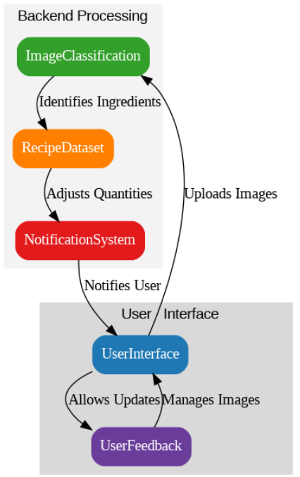

**Results**

**1. Overview of Outcomes:**

The AI Kitchen Model successfully integrates AI to assist users in preparing customized dishes. It identifies ingredients from uploaded images, adjusts ingredient quantities based on the number of servings, and notifies users of any missing ingredients.

**2. Functionality Demonstration:**

Upon accessing the AI Kitchen application, users can select their desired dish from a list of recipes. After selecting the dish and specifying the number of servings, users can upload images of their kitchen ingredients. The AI model then processes these images to identify available ingredients and compares them with the required ingredients for the recipe.

**3. Performance Metrics:**

The AI model achieved an accuracy of 96% in identifying the ingredients from the uploaded images. This high level of accuracy ensures that users are provided with reliable information about ingredient availability.

**4. Enhanced User Experience:**

The new feature allowing users to replace or add to existing images has improved the user experience by providing more flexibility in managing the ingredient detection process.

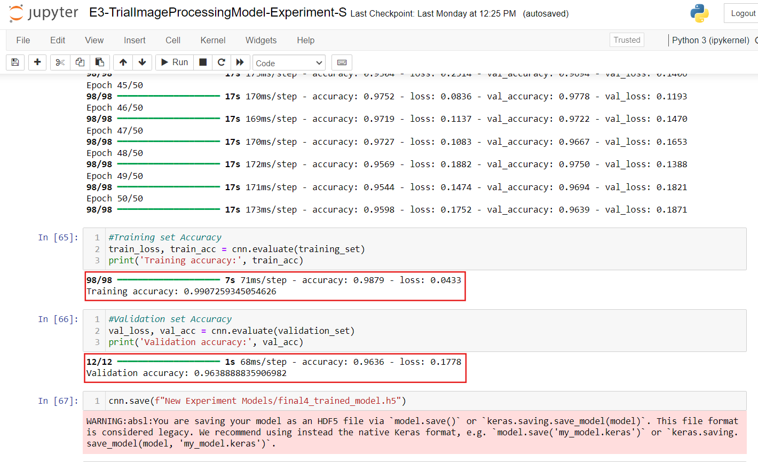

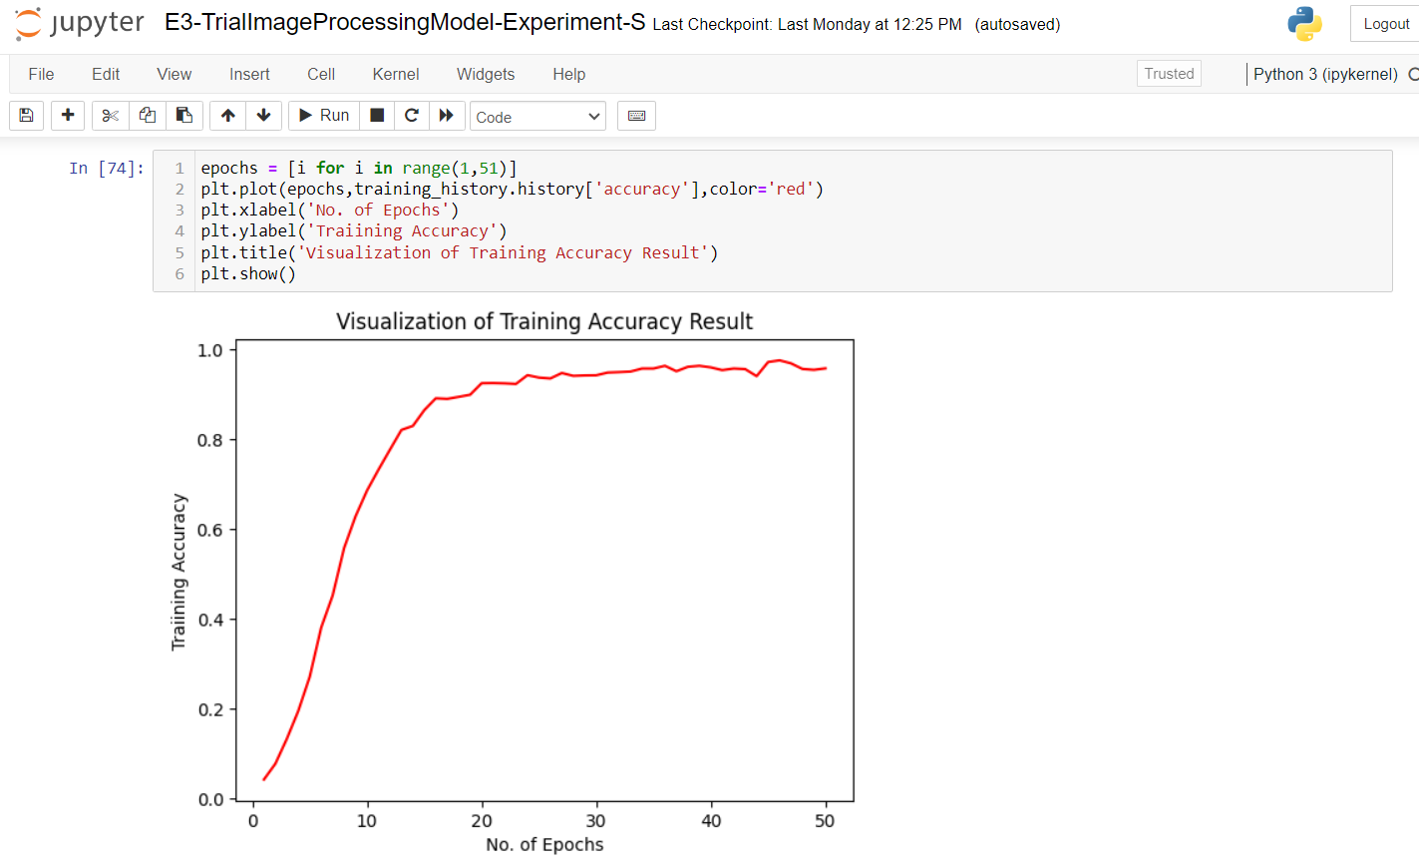

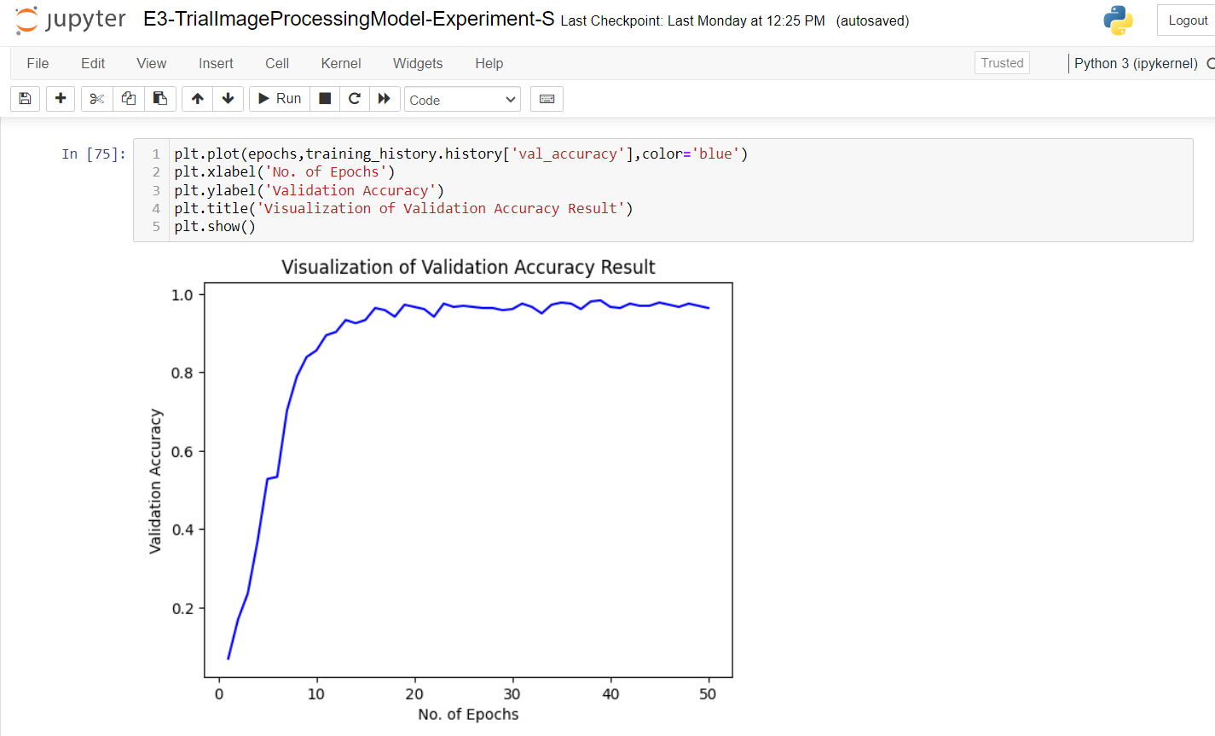

**Screenshots and Visuals**

**Home Page:**

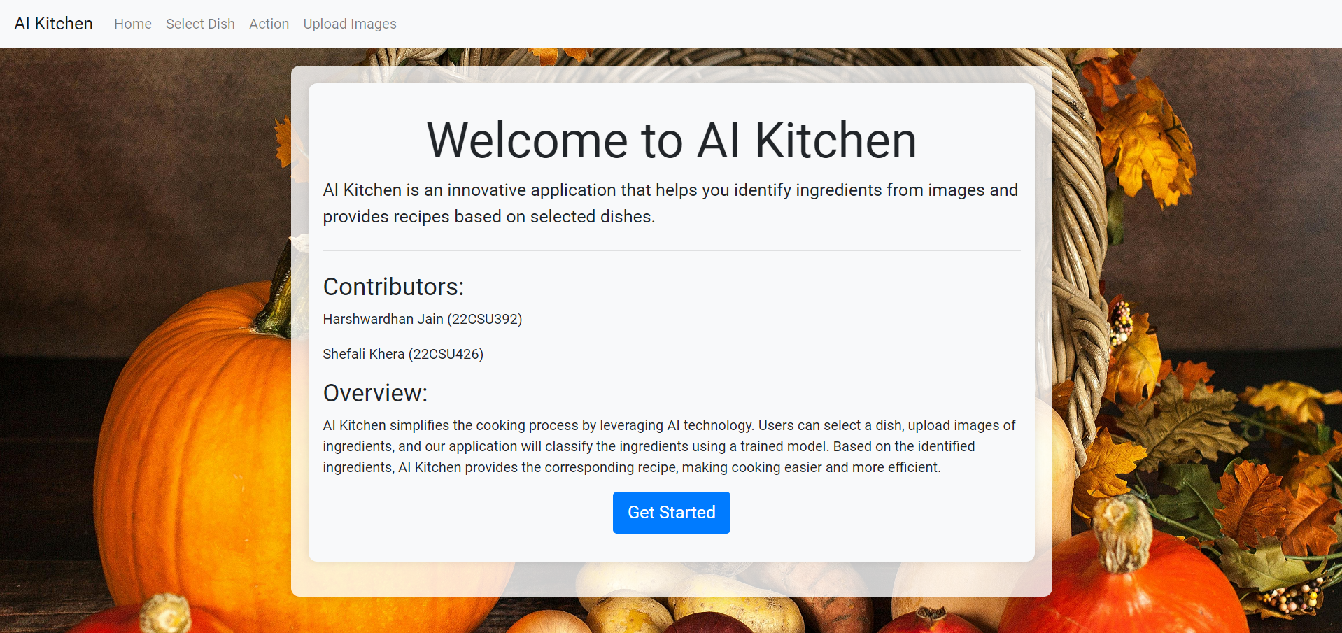

**1. Example Scenarios: Cooking a Cabbage and Carrot Sambharo for 4 People:**

**Step 1:** User selects "Cabbage and Carrot Sambharo" from the list.

**Step 2:** User specifies the number of servings as 4.

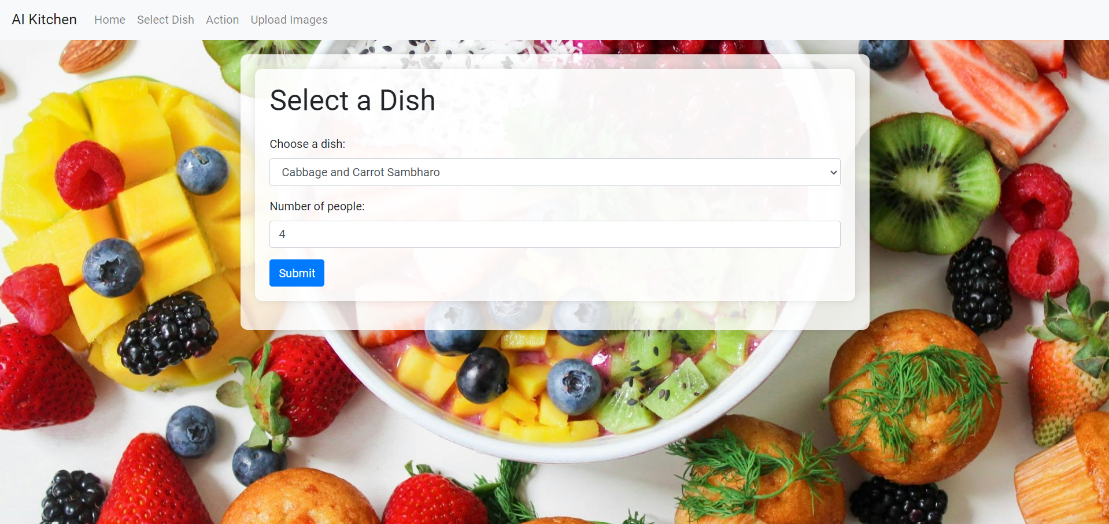

**Step 3:** User uploads images of the available ingredients.

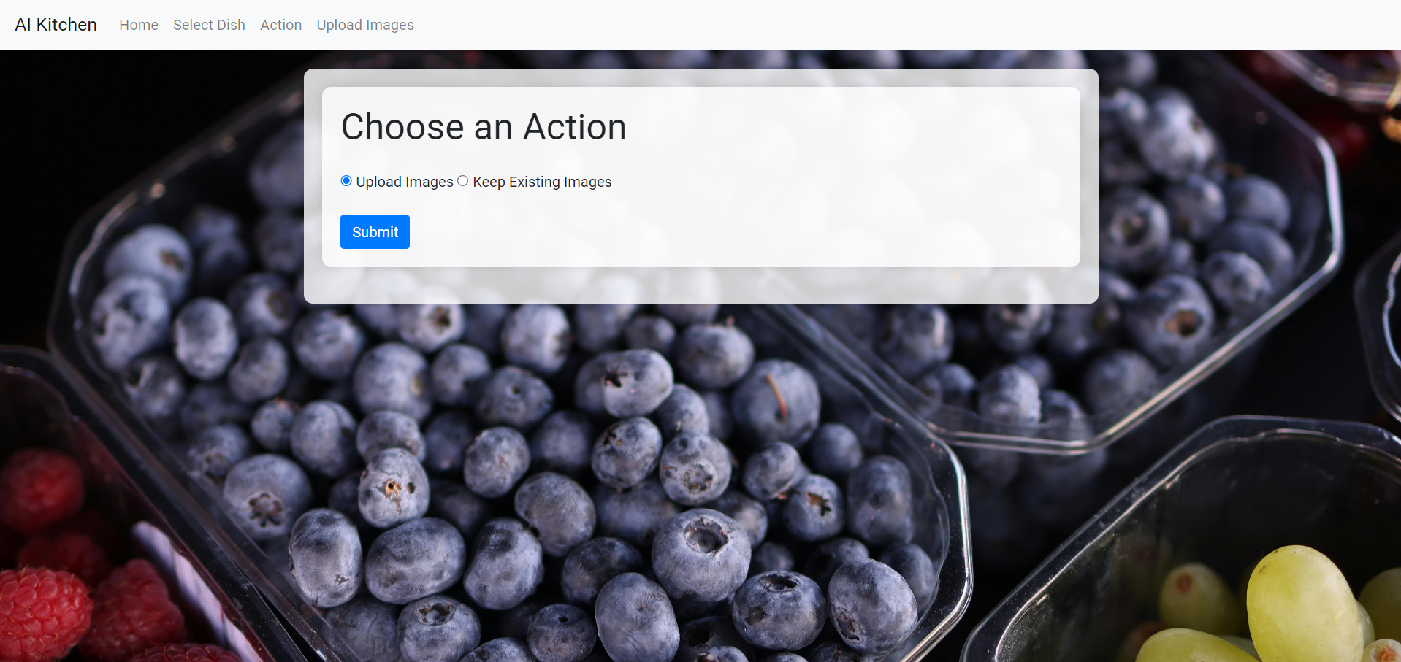

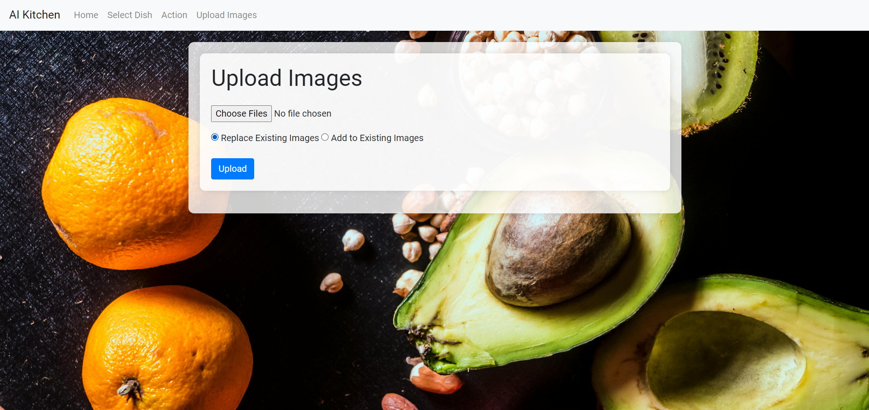

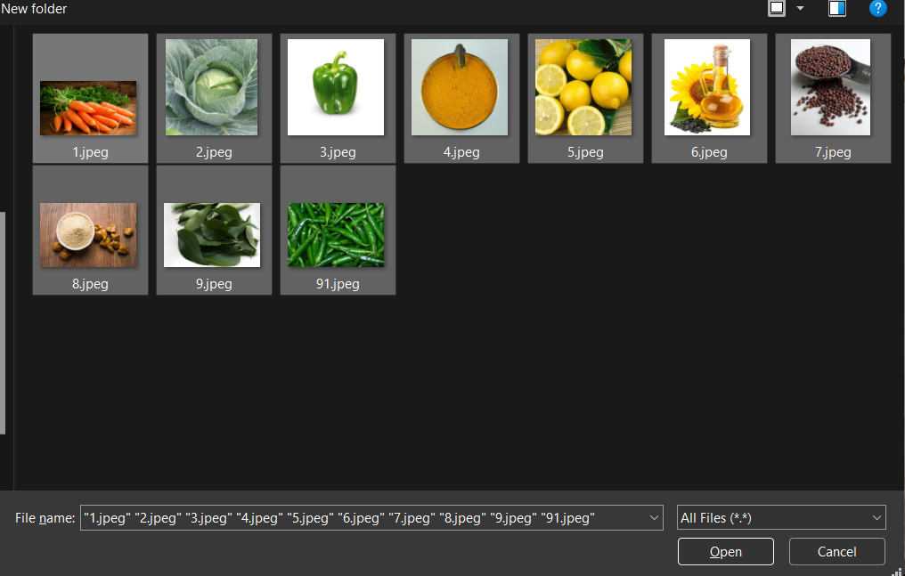

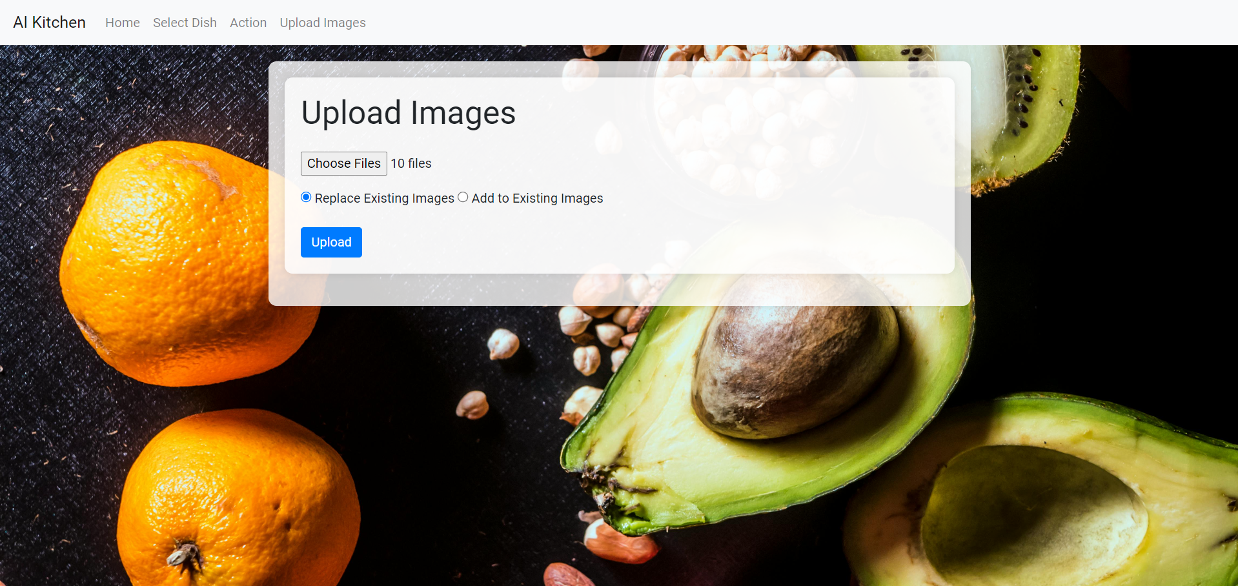

**Step 4:** The AI model identifies the available ingredients and adjusts the recipe quantities accordingly, if all ingredients are available.

**Step 5:** User receives detailed cooking instructions tailored to the ingredients on hand, if all ingredients are present.

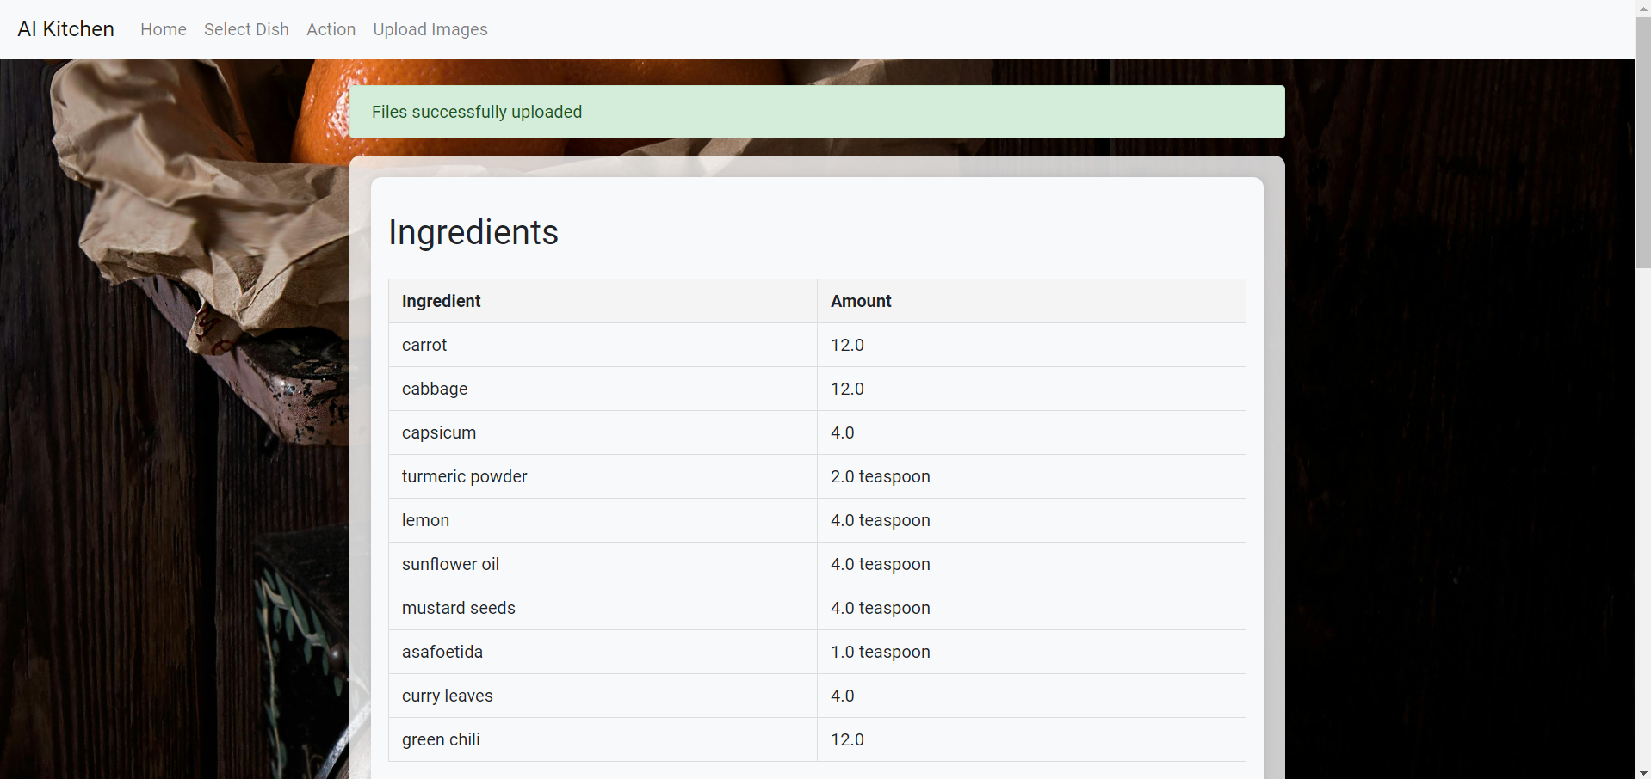

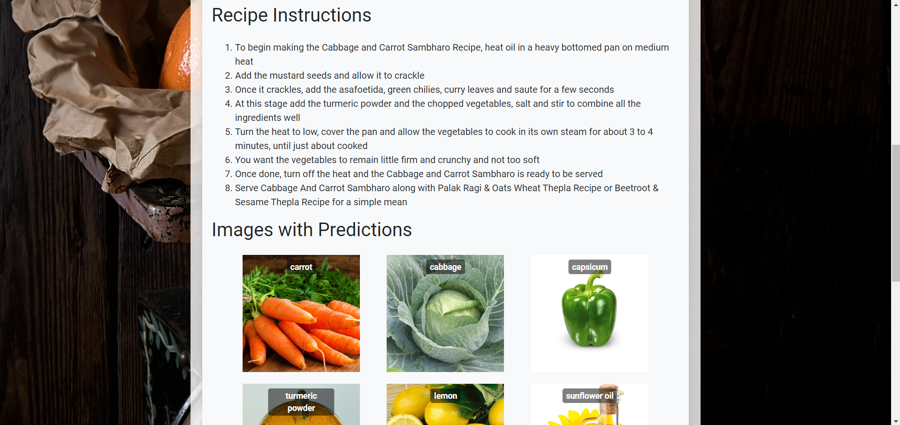

**Step 6:** The system notifies the user of missing ingredients, if all ingredients are not present.

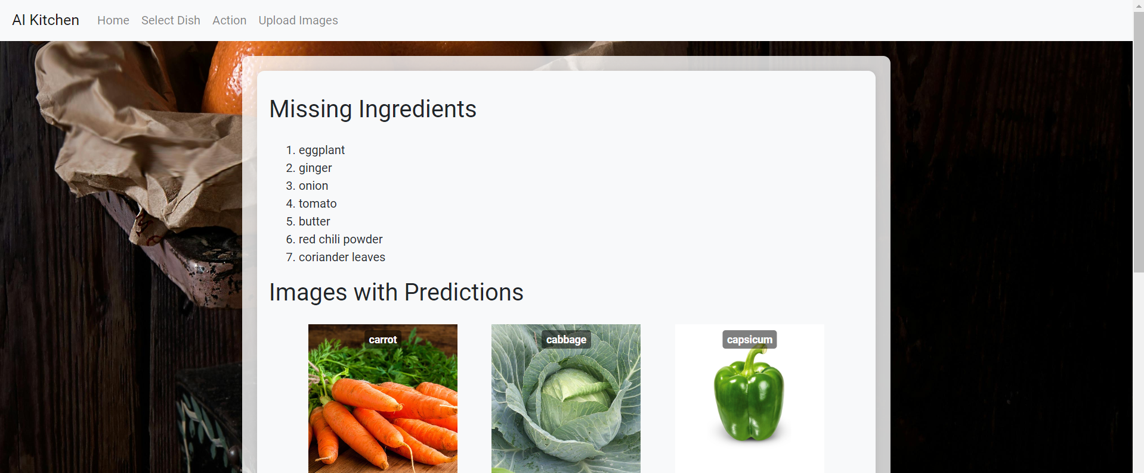

**Step 7:** The system prints all the uploaded images with their predicted names on top of the images, helping the user to verify the identified ingredients visually.

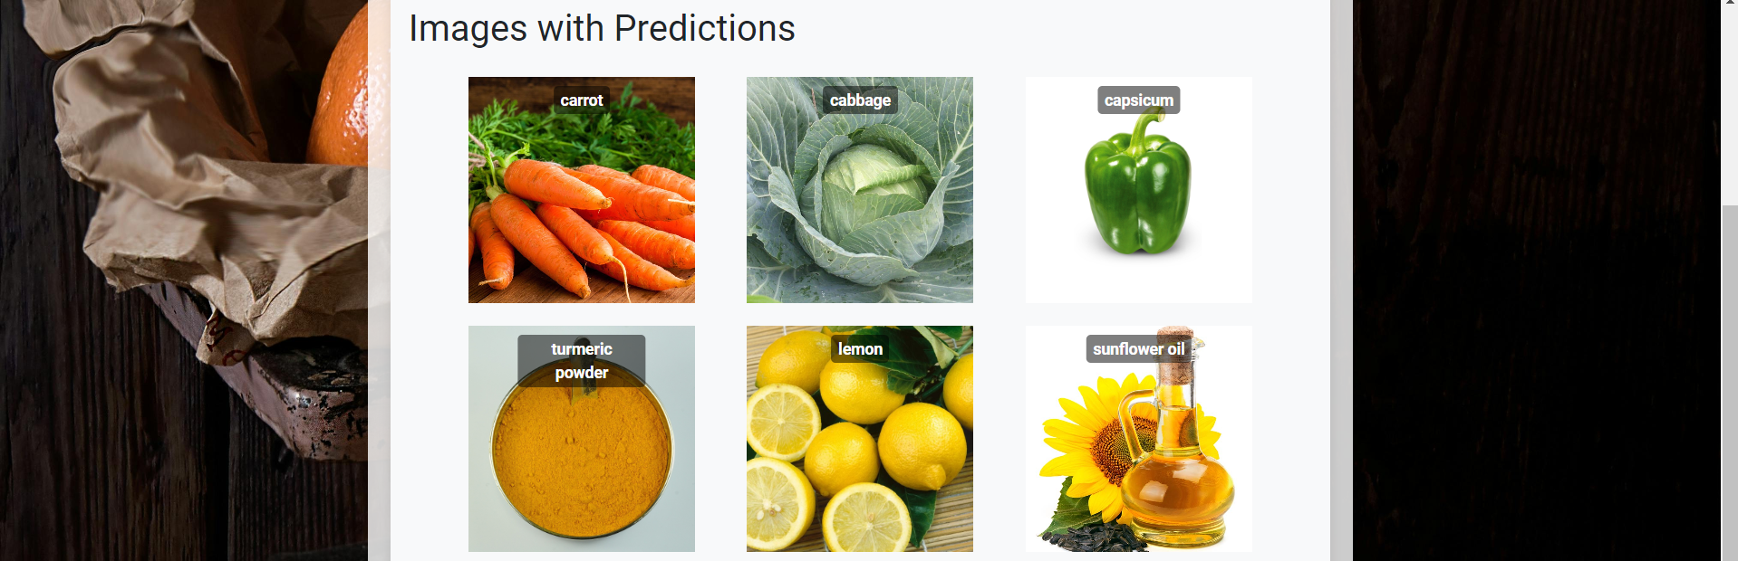

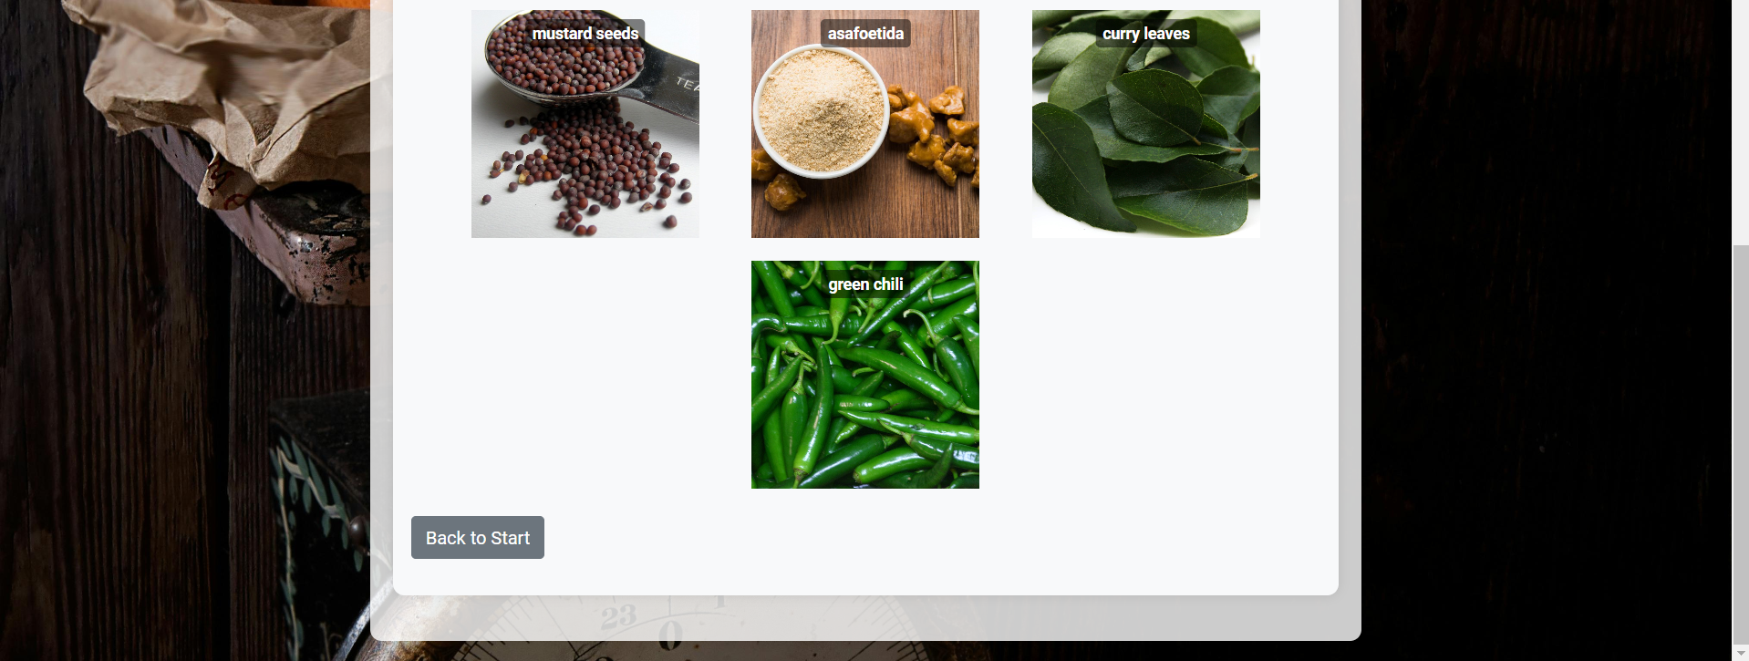

**Video Evidence**

<https://drive.google.com/file/d/1IubmF430K0-yJ00RVHuju5xy_Ud3prWC/view?usp=drive_link>